11Ice-0022
In-flight Icing Hazard Verification with NASA's Icing Remote Sensing System for Development of a NEXRAD Icing Hazard Level Algorithm
Author, co-author (Do NOT enter this information. It will be pulled from participant tab in MyTechZone)
Affiliation (Do NOT enter this information. It will be pulled from participant tab in MyTechZone)
Copyright © 2011 SAE International
ABSTRACT
From November 2010 until May of 2011, NASA's Icing Remote Sensing System was positioned at Platteville, Colorado between the National Science Foundation's S-Pol radar and Colorado State University's CHILL radar (collectively known as FRONT, or 'Front Range Observational Network Testbed'). This location was also underneath the flight-path of aircraft arriving and departing from Denver's International Airport, which allowed for comparison to pilot reports of in-flight icing. This work outlines how the NASA Icing Remote Sensing System's derived liquid water content and in-flight icing hazard profiles can be used to provide in-flight icing verification and validation during icing and non-icing scenarios with the purpose of comparing these times to profiles of polarized moment data from the two nearby research radars.
In this work, the authors present case studies to show how NASA's Icing Remote Sensing System can support the effort to develop a polarized S-band radar ‘Icing Hazard Level’ algorithm. With high temporal resolution range versus height scans from both radars over the NASA system location, detailed synoptic and micro-scale weather timelines for each case are analyzed. The new radar product, when combined with NIRSS, would provide crucial real-time hazard detection capabilities to improve aviation safety in the near-airport environment.
- INTRODUCTION
When air below the freezing point of 0○C becomes supersaturated with respect to water and ice, ice crystals begin to grow on freezing nuclei such as mineral dust, aerosols, other pollution particles or existing ice crystals by the process of diffusion (Rogers and Yau, 1988). In the absence of significant populations of such freezing nuclei, liquid water drops begin to condense out of the air from the water vapor. These drops are liquid that exist below freezing – or supercooled liquid water (SLW). In-flight icing occurs when an aircraft impacts with these SLW drops, which instantly freeze to the airframe. The resulting ice accretion builds up on the leading edges of the airframe’s control surfaces. Supercooled large drops (SLD), defined as drops larger than 50 µm, can accrete further back beyond the leading edges of the airframe where any existing ice mitigation technology would have no effect. Ice buildup while in flight acts to increase drag and reduce the aerodynamic lift generated by a vehicle’s control surfaces. Significant ice buildup can change an aircraft’s flight characteristics enough to be a significant safety hazard and has been recognized as a contributing factor to many crashes with resulting loss of life.
This study will focus on methods to utilize two ground-based remote sensing platforms with the purpose of providing accurate and timely warnings on in-flight icing hazard. One such platform is the national network of Doppler radars, known as NEXRADs (NEXt-generation RADars, or WSR-88Ds). These radars are designed to detect the presence of precipitation-sized particles, such as snow, rain and hail. However, the cross-sectional dimension of SLW drops are often several factors of ten smaller than these precipitation particle categories. One well known attribute of millimeter wavelength radars are that they tend to backscatter power from a target proportional to the sixth power of the target’s diameter (Bringi and Chandrasekar, 2001). This means that if a radar was viewing a sample volume that contained one large snowflake and a million much smaller SLW drops, the returned power to the radar receiver would be dominated by the single large snowflake. This fact limits the radar’s capacity to detect these small SLW drops which can accrete to make big problems for aircraft.
Existing NEXRADs transmit and receive only horizontal polarization, and thus measure reflectivity (REFL), radial velocity and spectrum width. Previous research with the singularly polarized 4-dimensional national NEXRAD mosaic (Serke et al., 2008) found that mixed phase conditions were virtually impossible to determine directly, however, data suggested that certain spatial relations might exist between SLW and the location and intensity of the radar reflectivity field. In cases with icing research flights, areas with reflectivity corresponding to ‘all snow’ had reflectivity generally above 20 dBZ with low spatial standard deviations. Higher SLW values existed in areas of reflectivity generally below zero, and in reflectivity gaps where the radar return was below the minimum detected by the radar at a given range. This work suggested that areas lacking SLW could possibly be identified with just radar reflectivity, which is an important step in qualifying the total airspace volume with respect to its icing status.
Presently, NOAA is preparing to upgrade the national network of NEXRADs so that they are capable of transmitting and receiving both vertical and horizontal radiation – known as ‘dual polarization’. This project is scheduled to be completed within two years. While polarized NEXRAD data are currently unavailable beyond the prototype KOUN radar in Norman, Oklahoma, two research radars exist along the Front Range of Colorado which have very similar characteristics to polarized NEXRADs. Dual-polarized radars collect additional information that can give researchers insight as to the mean particle shape, size, phase (liquid or solid), bulk density and preferred particle orientation in a given sampled volume. Polarized radars collect differential reflectivity (Zdr), correlation coefficient (ρ_{HV}), linear depolarization ratio and specific differential phase. Differential reflectivity is the ratio of horizontal co-polar received power to the vertical co-polar return. One way to interpret this field is a power-weighted mean axis ratio of the particles in the volume. Small liquid and cloud drops are nearly round, so Zdr values are near zero and small reflectivity. Larger drops become oblate as they fall and thus Zdr between 0.3 and 2.0 dB. Oriented ice crystals also have Zdrs that are positive and large. ρ_{HV} is the correlation between horizontal and vertical co-polar received returns. Wet or tumbling particles and mixed phase conditions result in decorrelation in polarizations so that ρ_{HV} values are typically below 0.92. Homogeneous rain or ice result in ρ_{HV} values above 0.95. Plummer et al., (2010) explored some of these polarized moment relations in regards to in-flight icing situations.
To further test the information content of the polarized moment data with respect to icing, the authors arranged a field campaign where radar data was collected during the winter of 2010/2011 during in-flight icing cases. One goal of this field campaign was to test the viability of an in-flight 'Icing Hazard Level' (IHL) algorithm (Smalley et al., 2009) for the National Weather Service's network of 150 soon-to-be polarized NEXRADs. The current incarnation of the IHL algorithm is a hybrid of several existing precipitation identification algorithms. For this study, testing was accomplished by exploring the vertical profiles of moment fields from the research radars at times of known icing and known absence of icing. In the absence of expensive icing flights flown with specially outfitted research aircraft, verification and validation of the presence of in-flight icing were provided by pilot reports and by NASA’s Icing Remote Sensing System (NIRSS).

No single instrument has yet been developed which can unambiguously detect in-flight icing conditions. For this reason, combinations of sensors have been under development for some time to detect in-flight icing (Politovich et al, 1995, Bernstein et al., 2005). NIRSS is a prototype ground-based remote sensing platform used to detect in-flight icing that has been under development by NASA and NCAR since 2003 (Reehorst et al., 2006). The mandate of the NIRSS program is to detect in-flight icing in the near-airport environment with existing, relatively inexpensive technologies. A recent study found that NIRSS detects the absence, presence and severity of in-flight icing at least as well as the FAA’s current operational system to detect icing (Johnston et al., 2011). The second goal of this field campaign was to test and improve the prototype NIRSS.

- FIELD CAMPAIGN

Overview
To address the goals of this study, the authors brought the mobile NIRSS from its traditional home at NASA Glenn Research Facility in Cleveland, Ohio, to the Front Range of Colorado for the period of December 2010 to June 2011. It was deployed at the NOAA-owned Platteville site due to the site’s proximity to the CSU-CHILL radar, the NSF S-Pol radar as well being located under the flight path of commercial aircraft arriving and departing from Denver’s International Airport (DIA). The positions of the respective instrumentation for this field campaign are shown in Fig. 1. Proximity to DIA provided the best chance of being close to the greatest number of voluntary pilot reports of in-flight icing that might occur over the deployment period. Also, twice daily meteorological balloon soundings and surface condition reporting from DIA could be utilized for case study analyses. Platteville is also home to NOAA’s 449 MHz acoustic atmospheric wind profiler. Each instrument platform or source of comparison data are described in detail in the following paragraphs.

Instrumentation

2.2.1 Polarized research radars
The Front Range of Colorado was chosen for this experiment because it is home to two of the world's premier polarized S-band research radars – Colorado State University's CHILL radar (CSU-CHILL) and NSF's S-Pol radar. CHILL (Fig. 2, Brunkow et al., 2000) is located 7 km northeast of Greeley, CO. S-Pol (Fig. 3) is located several kilometers southeast of Boulder, CO. Relevant characteristics of each radar are shown in Table 1, respectively. During icing cases, each of the two radars executed a scan routine which included several range versus height scans in the azimuthal direction of Platteville, followed by a series of stacked 360○ elevation scans which varied from 0.5 to 11 degrees. The stacked elevation scan volume was similar to a typical NEXRAD scan routine.
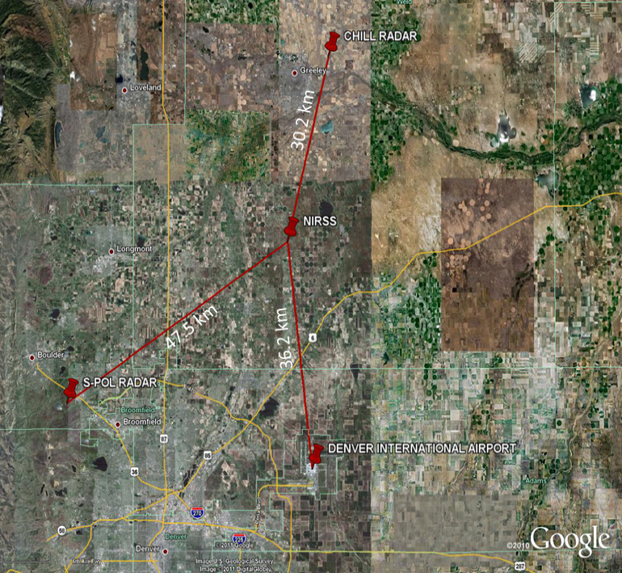
Figure 1 – Map of the Front Range of Colorado, showing the location of instrumentation platforms and distances to NIRSS.
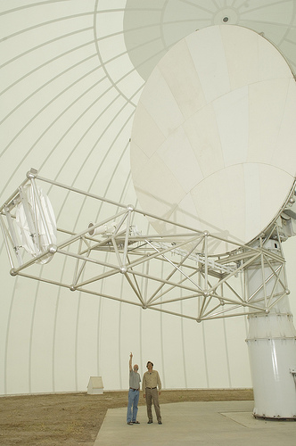
Figure 2 – The CSU-CHILL research radar near Greeley, CO.
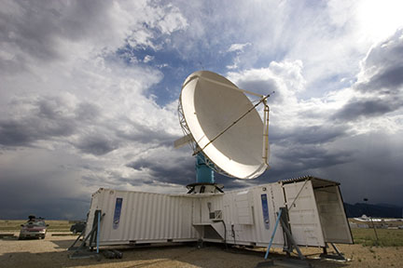
Figure 3 – The NSF S-POL research radar near Boulder, CO.

Table 1 – Characteristics of CSU’s CHILL and NSF’s S-Pol Radars.
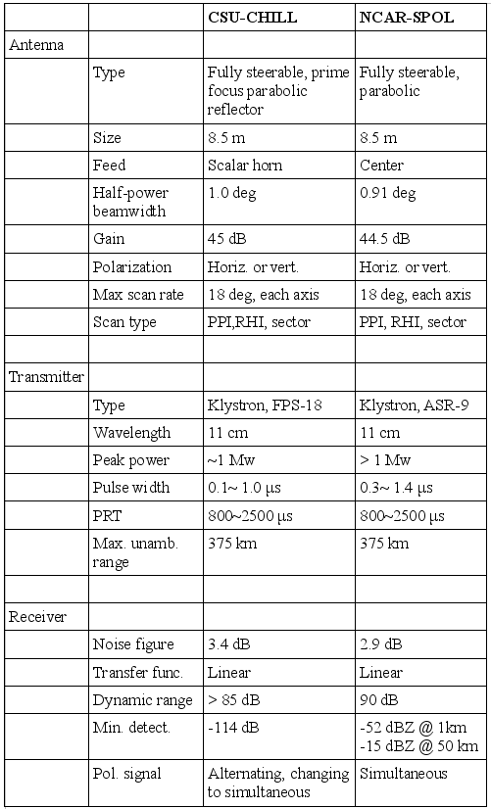

2.2.2 NIRSS
NIRSS consists of a vertically pointing Doppler K-band radar, a multichannel radiometer and a laser ceilometer (Fig. 4, Reehorst et al., 2006). The system employs a multi-channel radiometer built by Radiometrics Corporation which passively collects incoming microwave radiation at a number of channels in the K and V-bands of the electromagnetic spectrum (Solheim et al., 1998). The K-band lies within an atmospheric window and thus variations at specific frequencies within the band are due to variations in the amount of liquid and gaseous water. Different amounts of gaseous and liquid phase water cause the amount of microwave radiation received by the radiometer at frequencies frequencies within the K-band to respond differently. Algorithms used within the radiometer’s software compare the integrated liquid water (ILW) and integrated water vapor (IWV) of large historical archives of station sounding data to the inverted radiometric brightness temperatures from the instrument in order to arrive at ILW and IWV values for a given realtime radiometer profile. The V-band is on the shoulder of a major oxygen absorption feature, so that progressively varying frequencies from the peak of the absorption feature yields information on the atmospheric temperature further from the radiometer in range. This allows for the derivation of an atmospheric temperature profile. All input data streams are ingested into a ‘fusion’ machine and software is used to combine the instrument fields into an in-flight icing product. The height range of the 0 and -20º Celsius isotherms are targeted as the area where in-flight icing could exist. The vertical extent of cloud boundaries are provided by the ceilometer and K-band cloud radar. If cloud exists within the height range where icing temperatures exist, any liquid sensed by the radiometer is then distributed vertically with fuzzy logic based on previous experience with years of research flights in icing conditions (Reehorst et al., 2005).
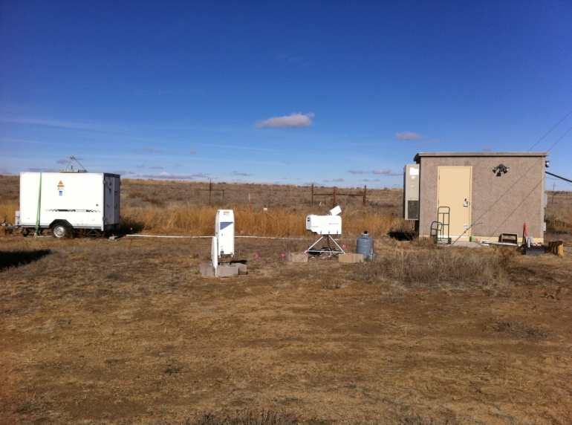
Figure 4 – NIRSS components stationed at Platteville, CO.

2.2.3 Pilot Reports
Pilot Reports (PIREPs) are voluntary reports made by commercial airline pilots of the time and location of meteorological conditions that their flight has encountered. In-flight icing is one of many possible conditions that can be reported. The existence of icing can be reported as 'no icing exists' or 'icing exists' as ‘trace’, ‘light’, ‘moderate’, ‘severe’ or ‘heavy’ severity. The authors converted these qualitative conventions to a 0-8 scale for ease of comparison. Over the course of the field campaign, over 250 icing PIREPs were reported within 50 km of NIRSS, 50 of which were within 25 km.

2.2.4 Precipitation and temperature observations
Surface observations of present weather and twice daily balloon-sondes from Denver International Airport are incorporated into the case study analyses in the following section. In mid-February, a Parsivel distrometer (Loffler-Mang and Joss, 2000) was located with NIRSS in order to quantify the time, size and number of precipitation particles. The importance of having precipitation data is that it can often give information about synoptic weather features and processes that are occurring in the atmospheric column.
- Case Studies
The method chosen to analyze the archive of in-flight icing cases collected during the 2010/2011 field campaign was to collect radar moment profiles at the exact times of interest based on the NIRSS ILW and icing hazard severity. Since it is difficult to discern the presence of mixed-phase conditions from just single profiles of S-band radar data, each time period of interest will portray all of the profiles within 250 meters of the NIRSS location. This corresponds to the 9 closest profiles from a given range versus height volume scan. This many profiles on a single plot becomes very busy, but important trends exist in the horizontal as well as the vertical standard deviations of moment data that will become evident through this plotting and analysis method. Similar work to this was done with horizontal standard deviations of NEXRAD reflectivity in a paper by Ikeda et al. (2009).
Over 250 icing PIREPs were collected within 50 km of the Platteville site during the campaign, but it became increasingly obvious that the scale of SLW features within the study area and the known inaccuracies of the time and location of PIREPs would not allow accurate comparison to our collected PIREP database. For this reason and the fact that the NIRSS testbed has proven itself significantly accurate when compared to past icing research flights (Reehorst et al., 2005), this study relied on the NIRSS ILW and icing hazard product to compare to the S-band moment data profiles as opposed to PIREPs. PIREP times and icing severities were only used as an indicator of the presence of in-flight conditions within the study area. Three icing case studies follow.
3.1 December 30 -31st, 2010
On December 30th, 2010, a strong Artic cold front combined with an upper-level low pressure system over Colorado to bring upsloping winds from the north and east over Platteville (Fig. 5). Since terrain slopes gently upwards toward the mountains from east to west along the Front Range of Colorado, any wind flow with a significant easterly component effectively lifts an air mass and is thus called ‘upslope’. This is one of the main forcing mechanisms for wintertime in-flight icing events in the region. The system brought periods of moderate snow and no associated icing PIREPs, interspersed with periods of no snow and moderate icing PIREPs.
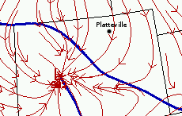
Figure 5 – Fronts (thick blue lines) and surface wind streamlines (red arrows) at 20:00 UTC on December 30th, 2010.
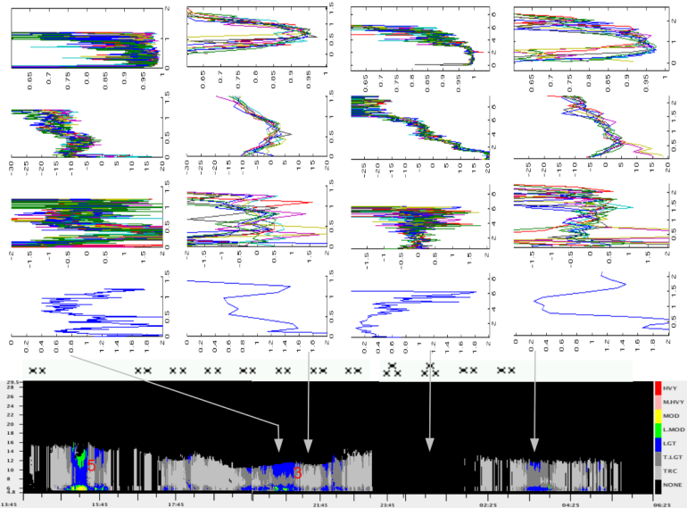
Figure 6 – Plot of the ten closest vertical profiles of CHILL ρ_{HV} (top row,[%]), REFL (second row,[dBZ]), Zdr (third row,[dB]) and horizontal standard deviation of Zdr (fourth row)to Platteville, CO on December 30-31st 2010 at the times shown by the grey arrows on the time/height plot of NIRSS icing hazard (bottom row, color scale). A time series of observed weather from DIA is also shown (symbols).
Fifteen icing PIREPs were reported within 50 km of Platteville during this case. Surface temperatures were below freezing for the entire case study period (not shown). NIRSS detected these periodic icing times well (Fig. 6, bottom row). CHILL began operations at 17:40 UTC and continued through the end of the icing case on December 31st. At 20:26 UTC, NIRSS detected moderate icing. CHILL moment data from this time are plotted in the first column of Fig. 6 as 9 different colored profiles for each moment field. CHILL detected only REFLs below 0 dbZ, with a discrete second layer of even lower REFL above 0.6 km AGL. Values for ρ_{HV} were above 0.9, but with significant variability especially in the upper cloud layer. Zdr in the upper layer was centered near 0.0 dB and had the lowest horizontal variability. One hour later at 21:20 UTC, NIRSS detected a rapid decrease in icing but still enough liquid for a ‘trace’ designation. CHILL saw an overall increase in mean REFL through the column and a more uniform vertical distribution of REFL from the previous time’s two discrete layers (Fig. 6, second column). There was somewhat more variability in the 9 Zdr profiles nearest to Platteville at this time compared to the previous time. An increase in the snowfall rate was recorded around 1:00 UTC on December 31st, and NIRSS detected no liquid and no icing hazard around this period. This is consistent with the theory of a uniform ice crystal population in the sampled profile effectively scavenging out any available liquid. CHILL moment profiles at this time (Fig. 6, third column) show REFLs above 0 dBZ up to 3 km AGL, which correlates to the moderate snowfall. ρ_{HV} was close to 1.0, indicating a uniformly shaped particle population. Zdr was close to 0 dB, which in this case is probably indicative of tumbling ice crystals. Horizontal variation of Zdr in this layer was also low. At 3:30 UTC, no precipitation was reported at the surface and NIRSS was indicating significant icing. REFLs were mostly below 5 dBZ, and Zdr was fairly variable except for in the cloud section centered at 1km AGL (Fig. 6, fourth column). Here, Zdr was centered on 0 dB and had a very low horizontal standard deviation.
3.2 January 9th, 2011
On January 9th, 2011, a surface low pressure system over north-central Colorado acted to create an upslope wind component along the Front Range of Colorado (Figure 7). The system brought periods of light snow showers throughout the day, interspersed with spikes of ILW. A total of 8 icing PIREPs were reported within 50 km of Platteville during this case. NIRSS’s icing hazard detection algorithm was unavailable this day due to a hardware failure on the K-band radar computer. The radiometer was still collecting data however, so a comparison of polarized moment data to ILW was still possible. Surface temperatures were below freezing for the entire case study period (not shown). NIRSS detected these periodic icing times well, and this case focuses on the time period between 16:50 and 18:30 UTC (Fig. 8, bottom row). CHILL began operations at 16:00 UTC and continued through the end of the day. At 17:00 UTC, NIRSS detected no ILW. CHILL (Fig. 8, first column) detected REFLs greater than 5 dbZ up to 3-km, with a rapid falloff of return above that level near the cloud top. RHO_{HV} values above 0.92 existed through the entire 3 km thick layer, indicating a uniformly shaped particle mass. ZDR values were generally above 0 dB in this layer, indicating a somewhat horizontally oriented particle mass. The horizontal standard deviation of ZDR was relatively low (0.3 to 0.7) within the main cloud layer. Larger horizontal variations exist near the cloud top, which was observed in almost every case study collected during the field campaign. At 17:44 UTC, a spike in ILW up to 0.2 mm occurred. REFLs increased to 15 dBZ at heights just above and just below 2 km AGL (Fig. 8, second column) compared to the previous comparison time. The ZDR values at 2 km AGL increased from +2 to +4 dB at the 2km AGL height. This may correspond to rapid growth in the population of oriented dendritic crystals associated with crystals rapidly growing at the direct expense of existing SLW. The horizontal standard deviation of ZDR shows a significant increase just below the height of the ZDR maximum, which likely corresponds to the micro-scale structure of this developing snow shower that was itself
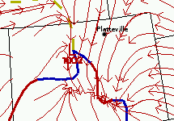
Figure 7 – Fronts (thick blue and red lines) and surface wind streamlines (red arrows) at 17:00 UTC on January 9th, 2011.
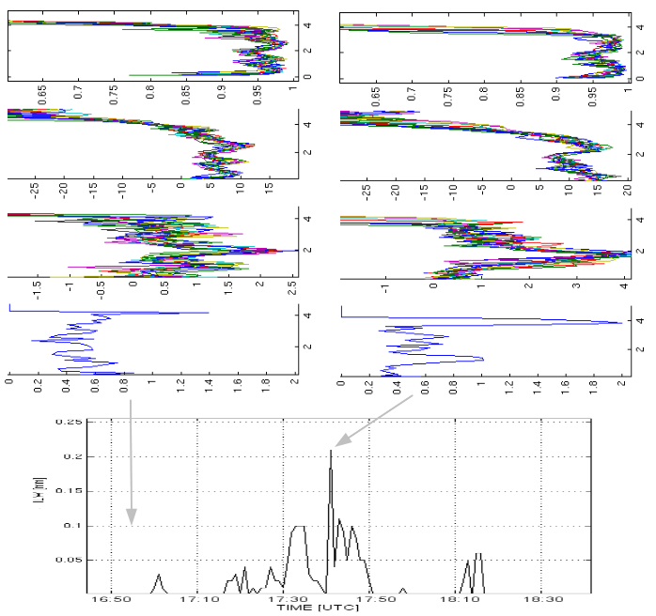
Figure 8 – Plot of the ten closest vertical profiles of CHILL ρ_{HV} (top row,[%]), REFL (second row,[dBZ]), Zdr (third row,[dB]) and horizontal standard deviation of Zdr (fourth row)to Platteville, CO on January 9th 2011 at the times shown by the grey arrows on the time series plot of NIRSS ILW (bottom plot, [mm]).
facilitated by oriented crystal growth from SLW. The pattern of a significantly positive Zdr mass embedded vertically within a Zdr profile that otherwise had a mean value of zero had been noted several other times during the field campaign. This pattern is likely indicative of mixed-phase cloud conditions and could be used in an algorithm to search out mixed-phase conditions in polarized moment volumes.
3.3 March 7st, 2011
On March 7th, 2011, a slow-moving surface low pressure system over north-central Colorado acted to create an upslope wind component along the Front Range of Colorado (Fig. 9) for a full 24-h period beginning at roughly 6:00 UTC. The surface precipitation was observed at DIA (Fig. 10, bottom) and by the Parsivel distrometer located at Platteville (data not shown) as periods of light showers and transitioned to fog and freezing drizzle by 9:00 UTC. A total of 17 icing PIREPs were reported within 50 km of Platteville during this case. Surface temperatures were below freezing for the entire case study period (not shown). NIRSS detected the start and stop times and vertical extent of icing very well when compared to PIREPs. CHILL began operations at 17:00 UTC and
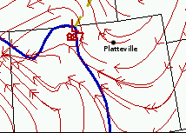
Figure X – Fronts (thick blue and lines) and surface wind streamlines (red arrows) at 20:00 UTC on March 7th, 2011.
continued through the end of the day. At 17:30 UTC, NIRSS detected light to light/moderate icing hazard values. Since this case was uniformly stratiform in nature all along the Northern Front Range for the duration of the case, and since the radar signal disappeared below the minimum detectable by the radar at about 10 km distance, analysis relied on the radar moment profiles at 5 km distance in the direction of Platteville instead of the 30 km distance that Platteville is from CHILL. CHILL (Fig. 10, first column) detected a very weak signal for this case due to the uniform liquid after 9:00 UTC. REFL at or below -20 dbZ existed through the cloud depth up to the tops at 0.8 km. ρ_{HV} values were extremely variable and never got above 0.90. Zdr values were extremely variable in this low return scenario. Previous research shows that Zdr values do not have any significant information content at these low signal-to-noise ratios. At time 21:45 (Fig. 10, second column) a light to moderate icing PIREP was recorded at 8,000 ft AGL. The radar profiles were much the same as during the previous time, with a shallow layer of very low REFLs and ρ_{HV} values significantly below 0.90.
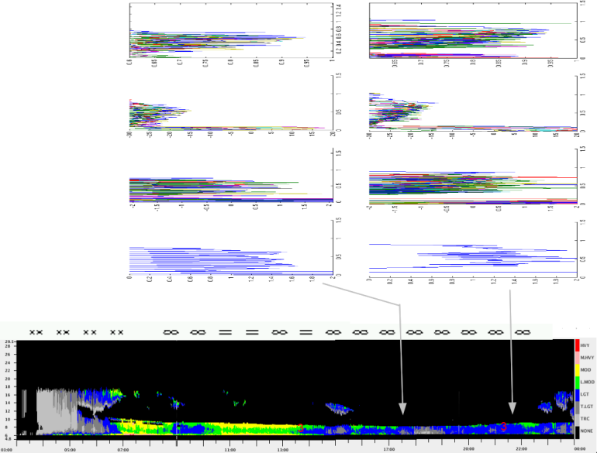
Figure X – Plot of the ten closest vertical profiles of CHILL ρ_{HV} (top row,[%]), REFL (second row,[dBZ]), Zdr (third row,[dB]) and horizontal standard deviation of Zdr (fourth row)to Platteville, CO on March 7th 2011 at the times shown by the grey arrows on the time/height plot of NIRSS icing hazard (bottom row, color scale). A time series of observed present weather from DIA is also shown (symbols).

- SUMMARY
During the winter of 2010/2011, NIRSS was positioned at Platteville, CO, between CSU’s CHILL and NSF’s S-Pol polarized research radars and underneath the flight-path of aircraft going to and from Denver’s International Airport. The purpose of this field campaign was to further test the prototype NIRSS system as well as provide in-flight icing verification data to compare to the moment data from the polarized research radars. This work was conducted to determine the overall feasibility of using polarized precipitation radar fields to construct an ‘Icing Hazard Level’ algorithm for the soon-to-be upgraded national network of S-band NEXRADs.
The authors have analyzed multiple polarized radar moment profiles within 0.5 km of the vertically staring NIRSS during periods of no icing, low and significant icing for all icing events during the winter field campaign and have observed several signatures in the moment profiles that could be utilized. A lack of icing has been seen to be characterized by REFLs generally above 15 dBZ and ρ_{HV} above 0.92. The relatively large REFLs are representative of ice crystal populations that have had time to scavenge out any available liquid, and elevated ρ_{HV} is indicative of a uniformly shaped particle population. In these instances, Zdrs are most likely to be near 0 dB due to the tumbling nature of the relatively large regular or irregular ice shapes. Horizontal standard deviations of all moment data in these ‘all snow’ cases are generally relatively small, as these snow cases have generally had time to develop horizontally and tend not to be cellular in nature. In mature ‘all snow’ cases, REFL tended to increase, Zdr tended to focus more toward 0 dB, and horizontal standard deviations of Zdr tended to decrease from the top to the bottom of the respective profiles. The most difficult positive icing scenarios for these polarized precipitation radars to detect appear to be homogeneous small or large drop icing. The signals returned from these SLW particles are very weak since the sizes of the SLW are generally smaller than typical precipitation particles. These cases often manifest as a ‘donut-shaped’ pattern close-in around the radar in fixed elevation scans. REFL can be from -15 dBZ down to the minimum detectable signal at the given range from the radar. Zdrs and other cross-polar fields are often meaningless at these extremely low signal-to-noise ratios. $ρ$_{HV} values in these cases have been seen to be highly variable but well below the 0.90-0.92 range seen in typical ‘all snow’ scenarios. These cases can be properly identified as homogeneous SLW cases by recognizing that the majority of these events are stratiform in nature and can thus be extrapolated up through the upper cloud limits at all locations between adjacent radars that exhibit similar return patterns at coincident times.
Mixed-phase cases have historically been the most important and most difficult problems for determining the existence of in-flight icing. Radar return is governed by the mean particle diameter to the 6th power, ensuring that the largest particles dominate. In this study, it was shown that several general patterns may exist in the temporally evolving vertical and horizontal radar moment fields that could be used to detect the presence of liquid in an otherwise glaciated cloud. One pattern for times of significant ILW, as viewed by NIRSS, was REFLs below 5 dBZ coexisting with Zdrs near 0dB that also had low horizontal standard deviations in Zdr. This indicates the presence of not many and/or not large ice crystals due to the relatively low REFLs. Zdrs near zero were consistent with cross-polar returns that were nearly identical – possibly due to a mean spherical shape as in liquid. The elevated layers of relative minimum horizontal standard deviation in Zdr are a pattern attributable to water. Previous studies (such as Ikeda et al., 2009) have shown the ‘smoothness’ in Zdr coincided with liquid, whereas more highly variable horizontal values were consistent with homogeneous ice phase. In another case discussed in this work, REFLs were between the somewhat arbitrary 5 dDZ threshold, below which defined ‘homogeneous liquid’ and above 15 dBZ which was used to define ‘all snow’ cases. ZDRs were seen to spike from +1 to +4 dB from a period where no ILW was sensed by NIRSS to a subsequent period when significant ILW was sensed by NIRSS in a narrow elevated layer of the cloud. These elevated Zdr features can be interpreted as rapid growth in horizontally oriented ice crystals due to scavenging of coexistent SLW. Such features were very highly time-dependent and were associated with much more cellular storm features than seen in the more stratiform ‘all snow’ or ‘homogeneous liquid’ cases. This was evidenced by the maximum in horizontal standard deviation of Zdrs just below the height of the SLW layer, which corresponds to microscale spatial variability in the location of the oriented crystals falling out below the SLW layer as a developing snow shower.
Future work includes more work on cases collected toward the end of the field campaign, ingesting and comparison of S-Pol data to CHILL during these times of interest and building an initial codebase to attempt to automatically quantify icing with NIRSS and polarized S-band radars in the Icing Hazard Level algorithm. NIRSS will be shut down and transported back to NASA Glenn research center in June 2011. NIRSS project tasking involves further testing and integration of the NASA Narrow-beam Multi-channel Microwave Scanning Radiometer (NNMMSR) into NIRSS in order to derive a volumetric icing hazard for the near-airport environment. It is hoped that the NNMMSR scan drive motor can be upgraded with new hardware so that the scan routine can be made to be synchronized with a typical NEXRAD scan routine. This would allow a future NIRSS version with an integrated NNMMSR to provide synergistic in-flight icing detection with polarized NEXRAD data, as was explored in this work.

References
- Bernstein, B., McDonough, F., Politovich, M., Brown, B., Ratvasky, T., Miller, D., Wolff, C., and Cunning, G., “Current Icing Potential: algorithm description and comparison to aircraft observations”, J. Appl. Meteor., 44, pp. 969-986, 2005.

- Bringi, V. and Chandrasekar, V., “Polarimetric Doppler Weather Radar – Principles and applications.”, Cambridge University Press, 656 pp., 2001.

- Brunkow, D., Bringi, V. N., Kennedy, P, Rutledge, S., Chandrasekar, V., Mueller, E. and Bowie, R., “A description of the CSU–CHILL National Radar Facility”, J. Atmos. Ocean. Tech, 17, Issue 12, pp. 1596-1608, 2000.

- Ikeda, K., Rasmussen, R., Brandes, E. and McDonough, F., “Freezing Drizzle Detection with WSR-88D Radars”, J. Appl. Meteor. Climatol., 48, 41–60, 2009. [doi: 10.1175/2008JAMC1939.1]

- Johnston, C., Serke, D., Adriaansen, D., Reehorst, A., Politovich, M.,Wolff, C. and McDonough, F., “Comparison of in-situ, model and ground based in-flight icing severity”, AMS Conference Preprint, Seattle, WA, Jan 24-27, 2011.

- Loffler-Mang, M., and Joss, J., “An optical disdrometer for measuring size and velocity of hydrometeors”, J. Atmos. Ocean. Tech., 17, 130-139, 2000.

- Plummer, D., Göke, S., Rauber, R. and Di Girolamo, L.,“Discrimination of mixed- versus ice-phase clouds using dual-polarization radar with application to detection of aircraft icing regions”, J. of Appl. Meteor. and Clim., 49, Issue 5, pp. 920-936, 2010. [doi: 10.1175/2009JAMC2267.1]

- Politovich, M.K., B.B. Stankov and B.E. Martner, “Determination of liquid water altitudes using combined remote sensors”, J. Appl. Meteor., 34, pp. 2060—2075, 1995.

- Reehorst, A.L., Brinker, D.J., Ratvasky, T.P., “NASA Icing Remote Sensing System: comparisons from AIRS–II,” NASA/TM—2005-213592, 2005.

- Reehorst, A., Politovich, M., Zednik, S., Isaac, G. and Cober, S., “Progress in the development of practical remote detection of icing conditions”, NASA/TM 2006-214242, NASA, 2006.

- Rogers, R., and Yau, M., “A Short Course in Cloud Physics”, Elsevier Science, Oxford, UK, 1988.

- Serke, D. J., F. McDonough and M. Politovich, “Analysis of 3-D NEXRAD Mosaic reflectivity data collocated with research aircraft and satellite data: implications on in-flight icing”. 13th Conference on Aviation, Range and Aerospace Meteorology Preprint, New Orleans, LA, Jan 20-25, 2008.

- Smalley, D., Bennett, B., Hallowell, R., Donovan, M., and Williams, E., “Development of dual polarization aviation weather products for the FAA”, AMS Conference Preprint, 2009.

- Solheim, F., Godwin, J., Westwater, E., Han, Y., Keihm, S., Marsh, K., and Ware, R., “Radiometric profiling of temperature, water vapor and cloud liquid water using various inversion methods”, Radio Sci., 33, pp. 393-404, 1998.

CONTACT INFORMATION
David Serke, serke@ucar.edu, (303)497-8311, 3450 Mitchell Lane, Boulder, CO, 80301
Acknowledgments
This work was done under the NASA Aviation Safety Research Program AEST. The National Center for Atmospheric Research is sponsored by the National Science Foundation. Any opinions, findings and conclusions or recommendations expressed in this publication are those of the author(s) and do not necessarily reflect views of the National Science Foundation. The authors would like to thank and acknowledge the National Oceanographic and Atmospheric Association for allowing us to locate our instrument platform at their Platteville Atmospheric Observatory site. The authors would also like to thank and acknowledge the Colorado University Space Physics Group led by Dr. Scott Palo for allowing us the use of their internet connection at Platteville.
DefinitionS/AbbreviationS
NASA - National Aeronautical and Space Administration
FAA - Federal Aviation Administration
NCAR - National Center for Atmospheric Research
CSU – Colorado State University
NSF - National Science Foundation
NOAA - National Oceanic and Atmospheric Association
DIA – Denver International Airport
NIRSS - NASA Icing Remote Sensing System
NNMMSR – NASA Narrowbeam Multichannel Microwave Scanning Radiometer
CHILL - University of Chicago and University of Illinois S-band Radar
SPOL - National Science Foundation’s S-band Polarized Radar
FRONT - Front Range Observational Network Testbed
REFL - reflectivity
Zdr - differential reflectivity
RHO_{HV} - cross-polar correlation coefficient
NEXRAD - Next-Generation Radar
IHL - Icing Hazard Level algorithm
PIREP - Pilot report

